CODE ALPHA
2025(10th Dec –10th Jan)

BUSINESS & MARKETING STRATEGY

TASK-1

Market Research Report

Submitted by

SHAKILA R

III-YEAR

KATHIR COLLEGE OF ENGINEERING

Rapido

Introduction`

Rapido is an Indian bike taxi and ride-hailing company founded in 2015 and
headquartered in Bengaluru, Karnataka. It provides affordable and quick
transportation services such as bike taxis, auto rides, and cabs through a mobile
app. Rapido is mainly used for short-distance travel and helps people save time
by avoiding traffic in busy cities.

SWOT Analysis of Rapido

Strengths

Rapido offers affordable and economical transportation compared to traditional

cabs. Its bike taxi service helps users save time by avoiding traffic congestion in

busy cities. The mobile application is easy to use, which improves customer

convenience. Rapido also provides flexible income opportunities for riders

(called Captains), increasing driver availability.

Key points:

- Low-cost and affordable transportation

- Saves time by avoiding traffic congestion
- Easy-to-use mobile application

- High demand for short-distance travel

- Flexible earning opportunity for drivers (Captains)

Weaknesses
Rapido’s services are mainly suitable for short-distance travel and are not ideal for
long journeys. Bike taxis may raise safety concerns, especially during bad weather
conditions like rain. The company’s operations are limited in some cities due to
regulatory restrictions. Customer experience may vary depending on driver
behavior and availability.

Key points:

- Suitable only for short distances

- Safety concerns during rain or heavy traffic

- Limited service availability in some cities

- Customer experience depends on driver quality

Opportunities
Rapido has strong growth potential by expanding its services to more Tier-2 and
Tier-3 cities. The company can introduce electric bikes to reduce fuel costs
and support sustainability. Partnerships with businesses and delivery services can
help increase revenue. Improving safety features and technology can
strengthen custome trust.

Key points:
- Expansion into Tier-2 and Tier-3 cities

- Introduction of electric bikes

- Partnerships with delivery and logistics companies

- Improved safety features and technology

Threats
Rapido faces strong competition from ride-hailing companies such as Ola and Uber.
Government regulations and bans on bike taxi services in certain states pose amajor
challenge. Rising fuel prices can increase operating costs for captains. Safetyissues
or negative public perception can also affect the company’s growth.

Key points:

Strong competition from Ola and Uber.

Government regulations and bike taxi bans.

Increase in fuel price

Negative impact due to safety complaints.

3.Target Audience

Rapido’s main users are people who need quick, affordable, and convenient
short-distance travel. This includes:
- Students – need low-cost travel for college, classes, and daily movement.

- Office employees – use bike taxis to save time during peak traffic hours.

- Daily commuters – people traveling between nearby places within the city.

- Gig workers & delivery riders – they prefer flexible vehicles and shorter routes.

- Urban residents – city dwellers who want fast door-to-door transport without waiting long.
These groups value low cost, time savings, and easy ride booking through a mobile app.

4. Competitors

Rapido operates in a competitive market with several mobility companies.
Key competitors include:
- Ola – Provides bike taxis (Ola Bike), auto rides, and cabs with strong brand recognition.

- Uber – Offers UberMoto (bike taxi) and traditional ride services in major cities.

- Local services – Smaller regional bike taxi or auto services in some states.

- Traditional transport – Autos, scooters, and public buses also compete for short-distance riders.
These competitors push Rapido to improve pricing, service quality, and coverage

5.Graph

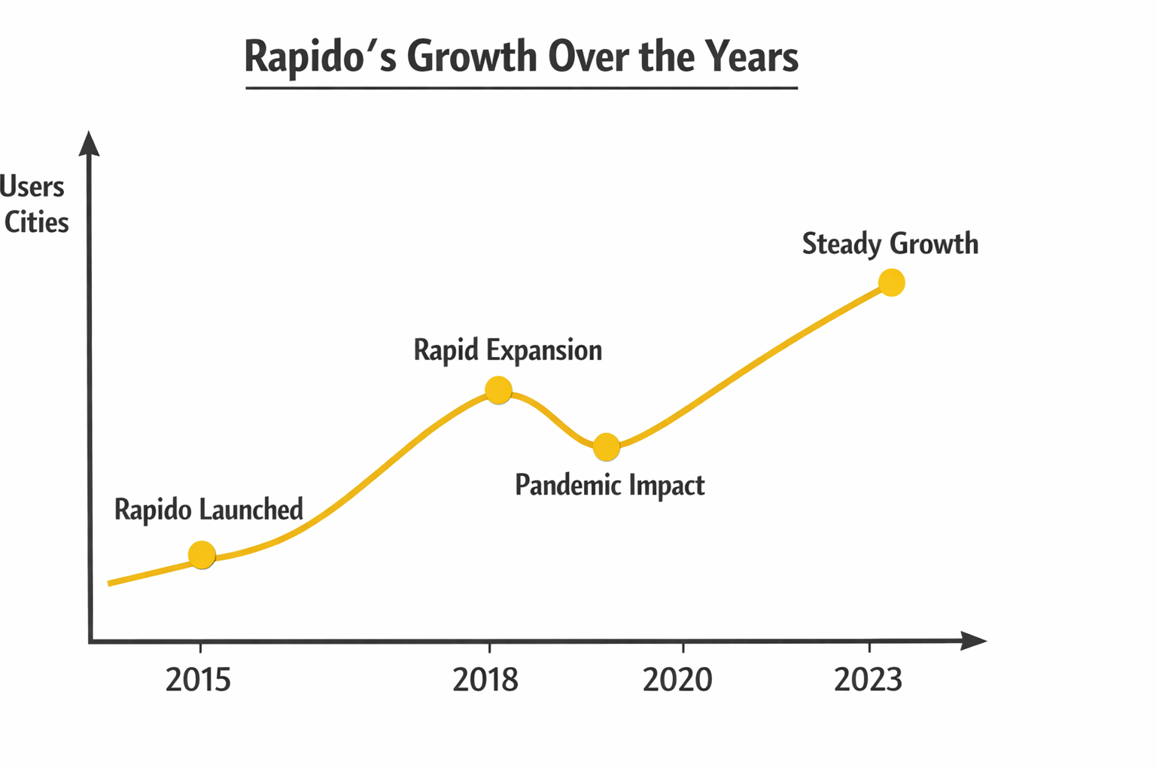
Here’s a summary of Rapido’s growth timeline:
- 2015 – Founded: Rapido started as a bike taxi service in India. Initially, operations were small, mainly in a few cities.

- 2016-2017 – Early Expansion: Rapid growth in cities like Bangalore, Pune, and Hyderabad. Rider registrations increased.

- 2018 – Funding & Growth: Raised Series A funding; expanded to 30+ cities.

- 2019 – Major Expansion: Presence in 100+ cities; more users and riders; app downloads surged.

- 2020 – Pandemic Impact & Recovery: Some slowdown during COVID lockdowns, but later adoption increased with safety measures.

- 2021-2022 – Diversification: Started delivery services (Rapido Bike Delivery), and app features increased.

- 2023 – Current: Operating in 100+ cities with millions of rides; steady growth in users and revenue.

📊 If we plot a simple line graph with Years (X-axis) vs Growth (Y-axis, could be number of rides, cities, or users), it would look like a steadily rising curve with small dips around 2020 (pandemic).

6.Graph

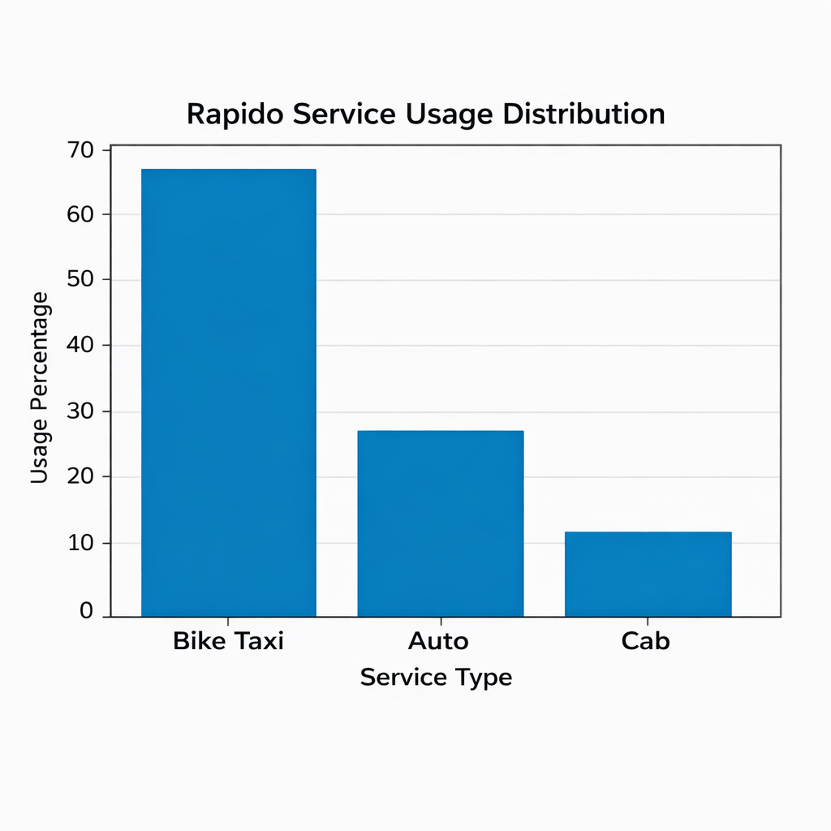

Explanation:

- The horizontal axis (X-axis) represents the types of services offered by Rapido:
Bike Taxi, Auto, and Cab.

- The vertical axis (Y-axis) represents the usage percentage of each service.

Service-wise Analysis:

- Bike Taxi (about 65%)
Bike Taxi is the most used Rapido service.
Customers prefer it because it is affordable, saves time, and helps avoid traffic.

- Auto (about 25%)
Auto services are moderately used.
They are preferred by users who need more comfort or are traveling with luggage.

- Cab (about 10%)
Cab service has the lowest usage.
This is mainly due to higher fares and is usually chosen for longer or more comfortable trips.

7.Diagram

Customers (App Users)
↓
Rapido Mobile App
↓
Captains (Drivers)
↓
Transportation Service

Rapido Service Flow – Explanation

1. Customers (App Users)
These are people who use the Rapido mobile application. Customers book a ride by selecting their pickup location, drop location, and preferred mode of transport (bike, auto, or cab).

2. Rapido Mobile App
The Rapido app acts as a connecting platform between customers and drivers. It receives ride requests from users, identifies nearby available drivers, calculates fares, shows routes, and manages payments.

3. Captains (Drivers)
Captains are registered Rapido drivers. They receive ride requests through the app, accept the request, pick up the customer, and provide a safe and timely ride to the destination.

4. Transportation Service
This is the final service delivered to the customer. The customer reaches their destination conveniently, affordably, and on time using Rapido’s transportation service.

8.Conclusion

Rapido is a fast-growing bike taxi service that provides affordable, quick, and
convenient transportation, especially in urban areas. It helps customers save time
and money while offering flexible earning opportunities for captains (drivers).
With its easy-to-use mobile app, strong local presence, and focus on last-mile
connectivity, Rapido has created a unique position in the market. Although it faces
competition and regulatory challenges, Rapido has good growth potential by
expanding services, improving technology, and reaching more cities. Overall,
Rapido plays an important role in solving daily travel problems and supporting
urban mobility in India.

